Campbell United Methodist Church

The Weekly Sermon

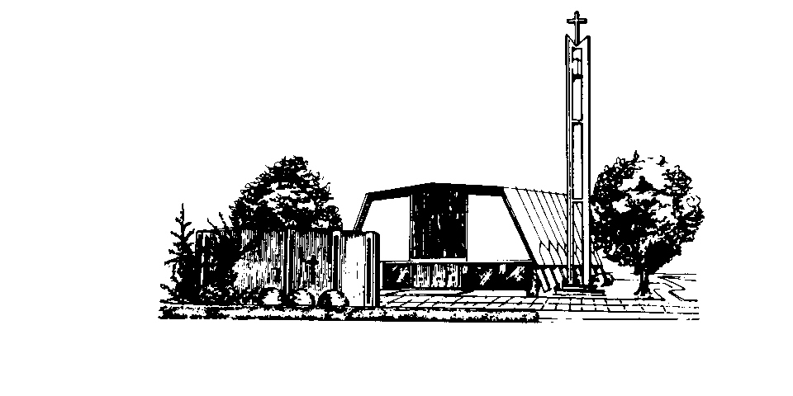

2nd Week of Advent: Knocking at the Door
Rev. Alan Jones
December 5, 2010
Isaiah 11:1-10, Matthew 3:1-12

When somebody knocks at the door of your home, you can often tell a lot about who is knocking from the sound of the knock… is it a strong thump, a gentle tapping or a persistent pounding. The knock can quickly tell you a lot about either the personality of the person knocking or the urgency of their visit.
The trick is, of course, to hear the knock… especially if we are ready to open, but aren’t sure about when and to whom the door should be opened. Boris Pasternak tells us:
When a moment knocks on the door of your life, it is often no louder than the beating of your heart, and it is very easy to miss it.
The first step of course, as we discussed last week, is to be awake. If we’re sleeping then the knock has to be much more jarring and unsubtle to get us up and walking to respond. It is also often hard to hear the knock with the television on… this is both an actual and a metaphorical reality. You don’t have to be a conspiracy theorist to recognize that our complex electronic media are grasping and molding the minds of our generation in a way that seems to have dangerous echoes of George Orwell’s nightmare vision in 1984. There is so much noise that it is almost impossible to hear God knocking at the doors of our souls.
John the Baptist comes onto the stage of history pounding on the door. The last thing you can say about John is that he is subtle, diplomatic and careful. He is banging and pounding on the door of history. Just look at what he says… right off the bat–“Repent, for the Kingdom of Heaven has come near.”
If you’re thinking that John may be like one of those people calling your home trying to sell you something Good evening sir, and how are you this evening… No! John is straight to the heart of the conversation. And it is very personal, even intrusive. He says straight out Repent! Turn your life around! The inference is that you are heading in the wrong direction, and you need to be going somewhere else.
The extraordinary thing about John is that he apparently expected not only that people would listen, but that they would choose to pack up a brown-bag lunch and walk 20 miles out into the heat of the desert to hear him harass them. Apparently there was something really engaging about this man that drew crowds. He struck a nerve of truth as he proclaimed his words of judgment.
And then a group arrived from the local clergy association… and did he give them words of encouragement–Keep up the good work guys, you’ve got a tough job? No he didn’t… in his typical fashion he said instead “You brood of vipers! Who warned you to flee from the wrath to come? Bear fruit worthy of repentance… every tree unable to bear fruit is going to fall to the ax.”
So after this group of preachers had schlepped 20 miles through heat and dust he tells them that talking the talk isn’t enough… they have to confess and start walking the walk that matches their talk.
And then he wrapped up his sermon by saying that he doesn’t have the last word on the subject… somebody else is coming onto the stage of history who will baptize not with water, but with the Holy Spirit and fire. And if you think I’m being tough on you… just wait until this guy comes!
Let me interrupt myself at this point and say a word about the desert, the wilderness of Judea where this story is set. In the Judean mind, the desert is where God lives. That was why John deliberately chose not to go into the city to preach his message. For us I might say that the wilderness is any place where you can become absorbed in the powerful presence of God.
The wilderness is where you are alone, totally alone, really alone, with the ultimate issues of life, death and eternity. The wilderness may be in your own home, in a book, in a few crumbs of bread and a dip into the grape juice. The wilderness may be on a street corner where a homeless person lives or in the fields or sweat shops where decent human beings are oppressed. Sometimes, it is in a closet. Sometimes it is in an apartment. The wilderness is always where the cross of God is invisibly present. The wilderness is where God is, and where God can knock loud enough to be heard, to cleanse the contaminated ramblings of our minds and imaginations and hearts.
The wilderness is silence and quiet. It is for a moment, for a minute, for a month, for a lifetime, being still, absolutely still…and listening. God knocks and speaks in the wilderness of silence. The city is so noisy; so busy; so crowded in my mind. The wilderness is silence and God speaks to us through the silence. And the voice of God comes to us through a very unlikely personality. He really looks like a crazy guy… just dressed in a camel skin and a leather belt. And he has this bizarre diet of insects and honey. He says that his lifestyle cleanses his souls and helps him to see life more clearly. And somehow people could tell that he was onto something. In the midst of the noise of their lives, he was offering a profound peace and possibilities for a different kind of life.
In the wilderness, you actually hear the voice of God speaking. It is God who is at the door, using the voice of John “Be washed. Be cleansed of the pollution of old memories and guilt, old resentments, angers and revenge. Be washed of whatever is hurting your life and the lives of others.” Hear the voice, “It’s time for a new start. Your sins are gone. Love God with all you have inside, all your heart, mind, soul and strength …and love other people and you’ll find yourself loving yourself.” Be quiet. Be still. In the wilderness… and you’ll find yourself seeing the stars and hearing the sounds of the wind in the quietness of the wilderness. Be still and you will hear the voice of God. The wilderness is silence and God speaks to us through the silence.
So what does this all mean for us on the second Sunday of Advent 2010? I guess it means, as the spiritual says, Somebody’s knocking at your door! You may be a lifelong Christian, an old hand at living the Christian life… God is knocking. Our may be new to faith and the teachings of Jesus… God is knocking. You may see yourself as a good person, a loving person, a person with a passion for justice… God is knocking. You may be somebody who feels as though you have lived life in the background, or even in the shadows… God is knocking.
Somebody is coming knocking on our doors this Christmas ready to baptize us with the Holy Spirit and with fire. I’m not entirely sure what that will be like, but it sounds lively and challenging. So before we get too caught up in the sweetness of the Christmas story let’s be listening for the knock and be ready for some spirited fire.
And the starting place may just be at this table as we all come forward and share in the bread and the cup… hearing the words of grace, of forgiveness of profound love and delight in who you are as a child of God. Prepare the way of the Lord! Amen.

