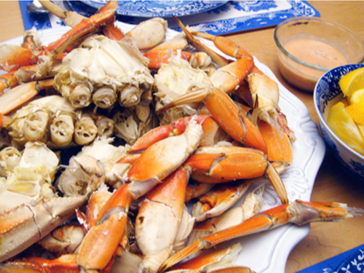 **You Are Invited!**

* All you can eat Crab
* Pasta or Clam Chowder
* Boudin's freshly baked garlic French bread
* Mixed green salad
* Dessert served at 7:00pm

Cake auction to follow Food prepared by Chef Juvenal Castro.



**Saturday, May 12th, 2018**

**Doors open 5:30pm; Dinner served 6:00pm**

**Pricing: Adults-$45 / Youth-$15 / Children-$10**

Entertainment featuring **Ren Geisick with Dolce Musica**

Enjoy Mother's Day Eve with the best dinner and awesome jazz entertainment!

[**TICKETS:** [**www.crabandallthatjazz.brownpapertickets.com**](http://www.crabandallthatjazz.brownpapertickets.com/)](http://www.facebook.com/events/1619481151463371%20)



**Campbell United Methodist Church**

**1675 Winchester Blvd**

**Campbell, CA 95008**

[**www.campbellunited.org**](http://www.campbellunited.org/)